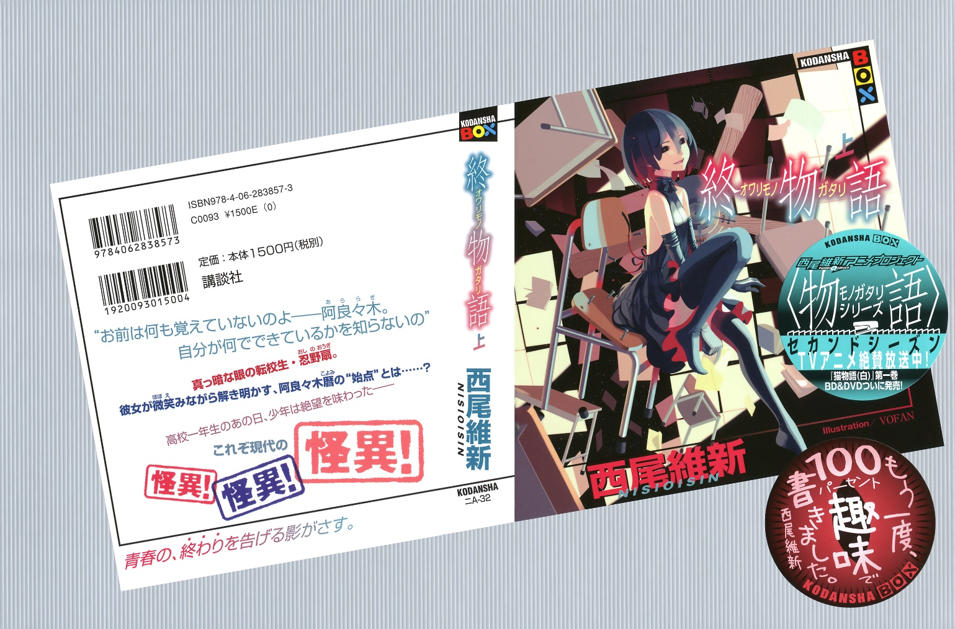Owarimonogatari (Vol. 1)

## **Sodachi Riddle**

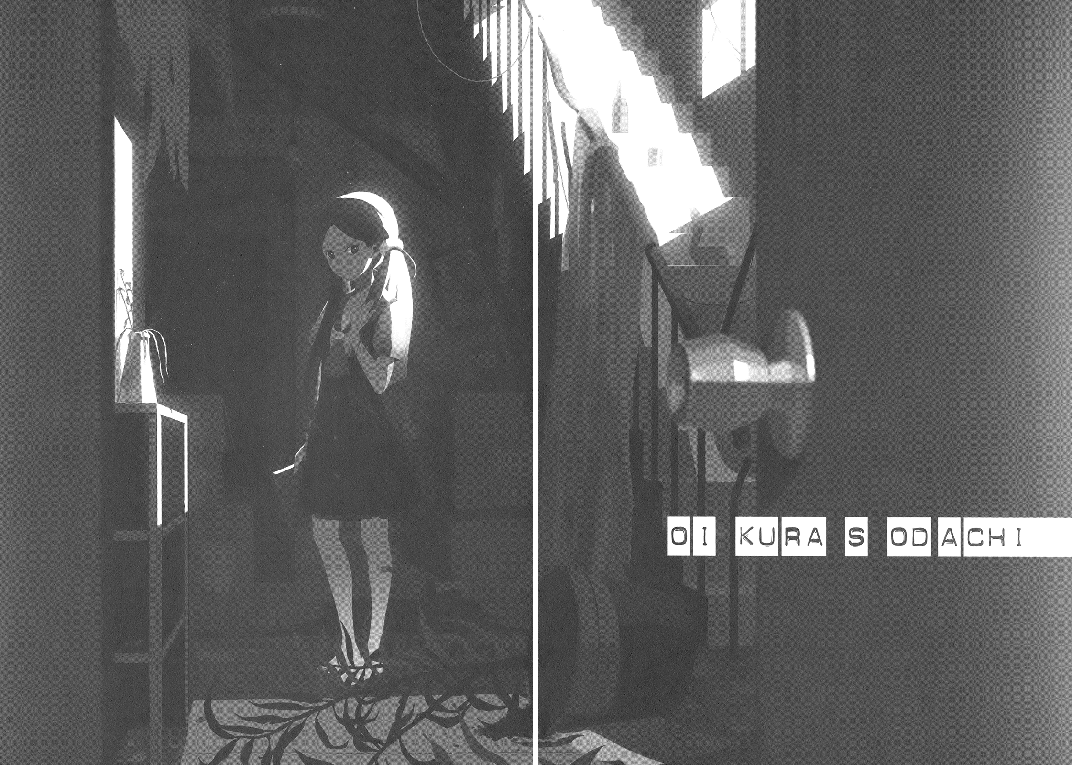

**004 (50%)**

(First half of chapter not yet translated. The scene is before class one morning in late October; maybe a week or two before Nadeko Medusa. Oikura Sodachi suddenly shows up after more than two years away from school. She's sitting in Araragi's seat. He tries to make conversation, it is not going well.)

"I hate you," she said clearly.

It was the same line she told me two years ago, in that classroom.

"I hate that attitude of yours: the way you try to wrap everything up ambiguously, the way you comprimise, make everything all tied up—like back then, when you—"

Almost saying it, she swallowed her next words.

Rather, it was more like her voice got stopped up, it looked as though she clogged her throat from the sudden outburst after a very long time of not being used to speaking much.

Indeed, she next cleared her throat.

I got closer to her, worried, and was denied with a "Don't touch me."

Now that's what you call curt.

"I don't want to be worried over by the likes of you. It's not like it'd do me any good."

"...... Is that so."

I back away, just as told.

And then I think. *Like back then, when you—*. The *back then* part I'm sure of course refers to tenth grade. Is she talking about how I tried to finish the class meeting all wishy-washy?

Now that you mention it, it was in response to that stance of mine that she resolved to take a majority vote. Though it was more an act of recklessness than resolution. Maybe she resents me for it. It was of course a misunderstanding, but from her perspective I'm sure that grudge of hers feels quite justified. If she's kept that grudge for these two whole years, then that certainly explains why she won't stop scowling at me.

It might not be right, but it's understandable.

"I h- hate you. I hate you. I HATE you."

Like a demagogue riling up the angry masses, she continued. It was like the dam broke. Heated by her own words, they drove her into a frenzy.

"I don't want to see your face. Your very existence is the worst thing in the world."

"... You must really," I began.

When the other side gets this agressive, I can't help but get more passive. I felt myself slowly chill. I settled into a calm in front of this beast. Like a mass of sediment. I suppose you could call it cooling in dumbfoundedness to her illogical words, but there was also the cold terror of not knowing what she would do, what would happen to me.

It was almost silly, comical how she could hate me so much. Not that I could laugh at it readily. If I could smile, It probably would have been an empty feigned smile.

A lot like the one Oikura's wearing right now. A twisted smile.

"You must really, hate happy people."

If you didn't want to see my face so much then why did you come to school, I almost wanted to say. But since she's had such a long absence and only now just managed to come to school, and saying that would be the same as saying *don't come to school,* I decided to speak in more general terms in order to dodge the attack.

But she shook her head as if to say *what is this idiot even talking about,* and said, "I like happy people."

... True, Oikura right now seems likely to disagree with whatever I might say. I say right she says left, I say up she says down. But in this case specifically she seems adamant about her position.

"Just watching them makes you feel happy, you know. What I do hate are those that don't know the reason for their own happiness. Those that don't even stop to consider why they are happy."

"......"

"I hate water that thinks it has boiled on its own. I hate the seasons that think they cycle around naturally. I hate the sun that thinks it rose by itself. I hate, I hate, h-, h-, hate—I hate it. I hate you."

Oikura's eyes were glimmering as she spoke.

Glimmering with a fiery blaze.

I had absolutely no idea that such a sickening glimmer even existed in this world.

"Hate hate hate hate hate. H- h- h-... hate. I hate everything. I hate it more than anything. I hate so hopelessly much. Hate, hate... hate and hate the hate with hate's hate to hate a hated hate I hate."

"Oikura..."

Oh fuck, I thought.

I had made a misunderstanding, and it was a doozy.

It was exactly the kind of misunderstanding people always make when they are under attack. Thinking themselves disadvantaged, that they are being subjected to violence by someone in a stronger position. I have to fight back, I have to step up the threat, or it'll get me. Though, maybe 'misunderstanding' is going a bit far. It's certainly true that if I don't fight, if I don't step up, I will indeed get a fair share of abuse.

Oikura is unmistakably being hostile to me.

She's unmistakably threatening and facing against me with a hostile stance. However, there's absolutely no way I can actually fight her back right now, whether I get abused by her or not.

Worst-case-scenario with the Oikura of two years ago? Maybe.

But not now.

Because Oikura right now... is fragile.

She's like a bit of glasswork. If I were to retaliate in self-defense in just the wrong way, if my hand were to brush against her only slightly, she's likely to break into tiny pieces. If I had indeed shot back with 'then don't come to school,' who knows how it would have turned out. Being faced against this kind of precarious mental state means that there's nothing I can do, nothing I can say.

Perhaps her first strike of meeting me while sat at my desk, instead of being an attack on me, was more an act of defense in order to protect herself, to protect her psyche?

She's completely out of balance.

I felt sick somehow.

For Oikura, as dignified as she was, to have shown up this weak, this frail—I'd have far preferred if she'd have come back way more threatening.

*That old enemy is back, and this time she's weaker!* —Who the hell wants to watch that.

In this situation, she's not a beast at all.

Oikura right now is more like a frightened little animal.

From her perspective, I'm the ferocious beast here.

I'm the predator.

I would be injured if I touched her, but she would shatter.

The difference in strengths make consideration and discretion *compulsory*.

"Why are you so quiet? You're not pitying me are you now, Araragi? Y- your pity isn't worth even a single yen to me."

"Wait. Oikura. Wait, wait, Oikura. Calm down. I'm gonna go somewhere for a second. Try to cool off while I'm gone. You can sit in that seat as much as you want—"

She did say that it was this attitude of mine that pissed her off so much.　She shot up, enraged. It was, in a way, consistent of her to stand the moment I said it was okay for her to sit, but this wasn't the time to be all impressed over it.

"Araragi. You. You. You don't know anything. You make your smug face, and without even thinking about why you are happy, you live so carefree. You don't know. You've forgotten. Exams? A girlfriend? Ge-, ge- ge- ge... get serious!"

"Bu-, but! Oikura!"

I am being serious, I went to say, but contradicting her wouldn't do any good. I suppose to her, my taking things seriously is probably the worst kind of screwing around I could do. But more importantly, when dealing with a mentally imbalanced person, you absolutely must not contradict them. Just as she disagrees with everything I say, I must agree with everything she says.

Or so I thought, but Oikura did not allow me even to agree with her. To make any remarks. Before I could speak she cut me off, before I could nod she expounds upon her thesis at once.

"A guy like you just throws his weight around. I'll never be rewarded. I hate it. Some guy that thinks he's living by his own strength. A guy that thinks he'd be able to live even by himself. Someone who boasts that he'd be able to survive on his own if it came down to it. Someone who can come out and say that he doesn't need the help of others. I hate him."

"......"

"**A person cannot become happy without the help of other people**. Some idiot that doesn't even understand that, I hate, I hate so much I could die."

What was it that pushed her this far into a corner?

Was it really that class meeting?

Or could it be the two dismal years after it?

Or could it be some other event that I'm not aware of?

"I-, I also think that cooperation is important. That's right, there's no way that people could only be able to save themselves, yeah. I'm always thinking, 'those ingrates that think they are only living by themselves are unforgivable.'"

I'm probably not cut out to be a yes-man. I had no idea it was this difficult to ingratiate myself to someone. Though I hope I could be allowed the minimum of an excuse that, even if it weren't me, I'm sure it would be impossible for anyone to keep pace with Oikura right now.

"The unforgivable one is you, Araragi. There's no one more ungrateful than you are. Your so-called 'justice' is egotistical."

"'Justice'?"

"**Or do you actually claim to remember?** What was inside your seventh-grade shoe locker."

Inside the shoe locker.

She said it so suddenly.

It felt as though the flow of conversation had be hacked in two. Inside my seventh-grade shoe locker? What the hell? I could see no meaning except that they were the words *seventh-grade shoe locker.* None at all. Picking up the confusion written on my face, Oikura replied, triumphantly, "That's what I thought."

"You don't remember anything, Araragi. You don't know what you're made out of."

You don't know... what you are made out of.

I don't know why, but her words struck me at my core. They pierced me, went straight through me, you could even say.

"... Oikura, what do you mean—"

"I don't mean anything by it! I hate meaning! I hate everything! I hate the hate and hate with hated hate that hate to hate by hate I hate! Hate hate hate hate hate hate hate hate hate hate hate hate hate hate hate hate hate hate hate hate hate hate hate hate hate!"

This is very bad.

Unfortunately this isn't my first experience seeing someone in this kind of state. And I'm aware that in these cases it's best to allow the person to just get it all out of their system, but when I say 'this is very bad,' the 'this' I am referring to is the fact that we are in a classroom with far too many people in it.

Regardless of how it unfolded, a certain amount of arguing and bickering could be explained away and settled as 'it was my fault.' It would be possible for me to take all of the disapproval upon myself.

However, her causing hysterics as intense and panicked as these might ruin Oikura's reputation within the classroom. Can only ruin it. Even through any rose-tinted glasses she might have been seen by due to suddenly coming to school after having been gone for so long.

Oikura Sodachi.

I had to calm her down somehow.

Thinking so, I grabbed her shoulder in support. Trying to appeal to her however I could, I rocked it, but before I could say anything—though of course it didn't matter what I'd have said, there was nothing I could have done to calm her down; if there was any correct way to handle this, then it probably would have been to turn tail and get the hell out of there—she screamed.

"I told you not to touch me!"

In a childlike tone.

Her action was also as mindless as a child's. There was a ball point pen on my desk, the desk currently under Oikura's occupation. An extra fine pen, who knows how it got there. It wasn't mine and I don't think it was Oikura's either. I could only guess someone had just *happened* to leave it there: it was, after all, exactly the kind of pen you'd see lying around anywhere at school. Oikura took it in hand, and swung it at my hand that was touching her shoulder.

"...... Ngh!"

Well.

I'm not saying this to be cocky (because with Oikura the way she is in front of me, what need is there?), but to be honest, I could have dodged it.

After the fierce battles I've been through for the last half year, I could have easily dodged a pen swung by a high-school girl—and a weakened one at that. But the tip sunk into the back of my hand.

It hit the metacarpal bone below my middle finger and stopped, it didn't pass through—to my relief. If the tip had pierced through and stabbed Oikura's shoulder that I was holding onto, then there wouldn't have been any meaning in not dodging it.

I can say this with absolute certainty:

If I had pulled my hand away and dodged it, then Oikura would have stabbed herself in her own shoulder. It was that much of an ill-thought, spontaneous, and mindless reaction.

In fact, the the violence of it seemed to have hit Oikura herself, regaining her a bit of composure.

"Ah..."

I could hear the regret in it.

But I didn't have the leeway to attend to her. There were two reasons why I had to hide the wound right now.

The first of course was for Oikura's future. It was a crime committed in broad view of the public, but none of the classmates around us were really watching very closely. If I hide the wound, it could be possible to pass this off with an interpretation of 'she didn't stab him,' 'she stopped right before.' ... Possible... probably. The other reason—and this one is far more selfish—and it's also the reason the "she didn't stab him" interpretation could possibly pass—is that, because of the lingering afteraffects of my vampirism, the wound would heal itself after only a moment.

I can't let anyone see me heal like that.

I didn't expect to recieve this kind of damage in the schoolhouse, but in any case this time, now that Oikura was in a shocked state, this time I had to get out of here. But just then—

While hiding the back of my hand I turned around. And then my legs stopped. They stopped dead in their tracks. Dead in their dead in their tracks. Not just my legs, everything stopped.

My flight, and my thoughts.

And that was because a certain figure caught my attention. The figure of one Senjougahara Hitagi, who had opened the door and entered the classroom.

Senjougahara.

Her attitude as deadpan as it once used to be—and far more deadpan than I'd ever seen it—she looked at my pen-stabbed hand, and then she looked at Oikura.

"......"

...... What happens now?